Harassment & Bullying Policy

This policy applies to all employees, apprentices, consultants, officers, contractors, interns, volunteers, job applicants, agency and casual workers. If you are an employee, this policy does not form part of your contract of employment. We reserve the right to amend it at any time. You should read this policy in conjunction with our Equal Opportunities Policy and Grievance
Policy. We want to provide a working environment free from harassment, bullying and intimidation. This policy applies in the following contexts:
● anywhere on the Company’s premises;
● anywhere off the Company’s premises during work-related social events, business events or business trips.
Taking part in any of the following behaviour will lead to action under our Disciplinary Policy, and this may lead to your dismissal for misconduct or gross misconduct:
● harassing or bullying anyone else (as defined in paragraphs 2 and 3 below);
● threatening anyone who raises a harassment or bullying complaint;
● retaliating against anyone who raises a harassment or bullying complaint;
● making allegations maliciously or in bad faith; and/or
● giving false or intentionally misleading information during any investigation.
Before you raise a complaint, you need to remember that the Company has a duty to protect all employees, workers and job applicants. That means that if you change your mind after complaining — even informally or in confidence — we may choose to investigate anyway. We will, however, not do so without talking to you first. You should never be victimised or treated less favourably if you raise a harassment or bullying complaint, and you must inform your Manager as soon as possible if you believe you have been subjected to this type of treatment.
If you are concerned about your own observations regarding the treatment of another, then sometimes the best approach is for you to challenge the behaviour or speak to your Line Manager informally regarding your concerns.
What is harassment?
Our definition of harassment relates to behaviour connected to what is termed a ‘protected characteristic’ (please see our Equal Opportunities Policy for the definition of this phrase).
We define harassment as any situation where a worker is subject to uninvited conduct that — as an intended or unintended consequence — violates their dignity in connection with a protected characteristic.
We also define harassment as behaviour that creates a hostile, humiliating, degrading or similarly offensive environment in relation to a protected characteristic. Name calling, lewd comments, excluding colleagues, making insensitive jokes, and displaying pornographic material are all examples of harassment.
Physical, verbal and non-verbal conduct can all amount to harassment. So can things you say or do online, especially on social media. This policy covers isolated or ongoing incidents of offensive behaviour. When someone treats another person less favourably because they either submit to such behaviour or refuse to do so, we also see that as harassment.
The impact on the victim is very important. People's behaviour can amount to bullying or harassment even if they had no idea it would be perceived that way.
What is bullying?
We define bullying as any behaviour that leaves the victim feeling threatened, intimidated, humiliated, vulnerable or otherwise upset. There is no need to demonstrate a connection with a protected characteristic to establish a bullying allegation.
As with harassment, physical, verbal and non-verbal conduct can all amount to bullying. It can take various forms, from extreme behaviour involving violence and intimidation, through to more subtle actions such as deliberate exclusion.
Constructive criticism about your behaviour or performance from your Manager or colleagues is not bullying. It is part of normal employment and management routine and should not be interpreted as anything different.

How we deal with harassment and bullying
Many issues can be resolved informally. Before you use this formal procedure, it's sometimes a good idea to speak with whomever you feel is harassing or bullying you and explain that their behaviour is unwelcome, inappropriate, or it upsets you. Surprisingly often, they might not realise that their behaviour is having that effect.
Sometimes it is difficult to speak with the perpetrator directly, in which case you should talk to your Manager informally and in confidence. Should the issue be with your Manager — or there’s another reason you would prefer not to discuss it with them — you should instead speak to their Line Manager or a Director of the Company.
If resolving the issue informally proves impossible, or you do not feel confident addressing the situation yourself, you should follow our Grievance Policy. We will treat your complaint in confidence, as far as is possible, and if we find that you have been the victim of harassment or bullying, we will take steps to stop it continuing or recurring.
Sometimes, if we think it necessary, we may need to separate you from the person you complain about while we investigate. If that involves moving you on a temporary basis, or even asking you to stay at home while we investigate, it is not a pre-judgment of your complaint. It is simply us trying to stop things getting worse during the investigation.
Should we decide that your complaint cannot be substantiated, we will explain why. Either way, we will look at ways of addressing your concerns such that you are happy with your work environment.
Protecting confidentiality
Harassment and bullying allegations can raise strong feelings and are always serious, which is why both the Company and the raiser of the complaint have an obligation to maintain confidentiality as far as possible. This applies at every stage, including the investigation and the outcome.
If you make a harassment or bullying complaint and fail to maintain proper confidentiality at any time during the process, or you are interviewed in connection with someone else's complaint and likewise fail to maintain confidentiality, you may face action under our disciplinary procedure and this could lead to dismissal for misconduct or even gross misconduct.

Just Surveys Limited will encourage the adoption of similar principles by its suppliers.

Signed
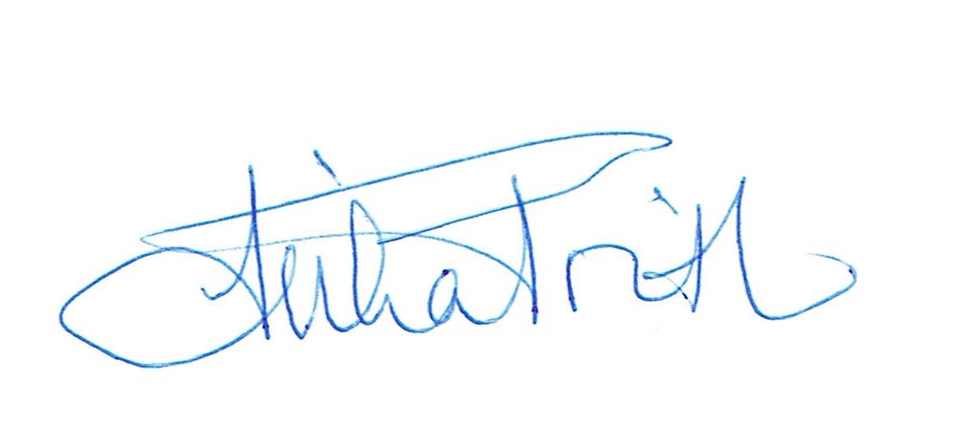

Reviewed 18/01/2024

