Equal Opportunities Policy

This policy covers all aspects of how you are treated by the Company and everybody who we employ. Matters it covers include (but are not restricted to) the following:
● pay and conditions of employment;
● training and continuing professional development;
● recruitment processes;
● promotion policies;
● procedures for appraisals;
● procedures for addressing grievances and disciplinary matters;
● ending the employment contract;
● providing outgoing employees with references;
● how visitors are treated;
● how clients and suppliers are treated; and
● how any other business contacts and associates are treated.
This policy applies to all employees, apprentices, consultants, officers, contractors, interns, volunteers, job applicants, agency and casual workers. We reserve the right to amend it at any time. If you are an employee, this policy does not form part of your contract of employment. You should read this policy in conjunction with our Harassment and Bullying Policy, and our Grievance Policy.

Our equal opportunities commitment and aims
We will not tolerate discrimination or harassment and are fully committed to promoting equal opportunities in employment. Our staff and anyone applying for a job with the Company will receive fair and equal treatment.
We ensure, where possible, full access to everyone applying for a vacancy. Decisions concerning transfers and internal promotions are made so far as possible using only objective criteria.
We will never victimise anyone who makes a legitimate complaint to us about harassment or discrimination.
How the law defines discrimination
The following list gives you a general description of the types of acts that may both breach this policy and be unlawful. Sometimes actions can be intentional, and sometimes unintentional. We include examples of both types in this list:
● direct discrimination: this is when somebody is treated less favourably because of a protected characteristic than somebody else has been, or would have been, in identical circumstances.
Examples: rejecting a job applicant because of their race, or refusing to promote someone because they are pregnant.
● indirect discrimination: this is when a group of people with one of the protected characteristics (subject to a couple of exceptions) is put at a disadvantage by a provision, criterion or practice applied to all staff unless the treatment is justified for a good business reason.
Examples: refusing a request to work part-time without a good business reason (which indirectly discriminates against women, who are more likely to have childcare responsibilities); insisting all staff work Saturdays without a good business reasons (which indirectly discriminates against Jewish employees, who may not be able to work on the Jewish Sabbath)
● harassment: this is when a hostile, humiliating, degrading, intimidating or similarly offensive environment is created in relation to a protected characteristic. We also consider it harassment for a worker to be subjected to uninvited conduct related to a protected characteristic that — as an intended or unintended consequence — violates their dignity.
Examples: name calling, lewd comments, excluding colleagues, making insensitive jokes, and displaying pornographic material are all examples of harassment. We deal in detail with harassment under our separate policy on harassment and bullying; and
● victimisation: in a legal context, ‘victimisation’ has a much more restricted meaning than in real life. It occurs when a worker has complained about harassment or discrimination, or supported a colleague in their complaint, and is then treated less favourably as a result.
Examples: an employee who is ‘sent to Coventry’ because they spoke up on behalf of one of their colleagues in a harassment investigation, or an employee who is dismissed under a pretext because they, themselves, have complained of discrimination.
The ‘protected characteristics’ are:
● age;
● race (which includes colour and ethnic/national origin);
● disability;
● religion or belief;
● sex;
● gender reassignment;
● pregnancy or maternity;
● sexual orientation; and
● marital or civil partnership status.
There are other actions which can be unlawful under the equal opportunity legislation.
Examples include:
● failure to make reasonable adjustments to minimise certain disadvantages suffered by a disabled employee (or job applicant);
● instructing another person (or applying pressure on them) to discriminate;
● knowingly assisting somebody else when they carry out a discriminatory act;
● discriminating against somebody believed to have a protected characteristic, whether or not they actually do, or because they associate with a third party who does.

How we carry out our responsibilities and duties
Both management and staff are essential for ensuring the success of this policy and each has their own duties and responsibilities. We all have a legal responsibility to comply, and any of us — management and staff — may be found personally liable for unlawful discrimination if we breach the terms of this policy.

Overall responsibility for the effective implementation and operation of the policy lies with management, specifically with the Managing Director. Everyone working at managerial level is expected to act in full accordance with this policy, lead by example, and attain and maintain appropriate standards of behaviour within the teams they manage.
The ethos and standards covered by this policy can only be achieved and maintained if all staff also cooperate fully, and it is important to understand that you also have a legal responsibility to comply. If you breach this policy, you may also make the Company liable for your actions and both of us may have to pay compensation to anyone who claims against us. We accordingly expect you to take personal responsibility for adhering to this policy’s aims and commitments and for drawing any breaches to our attention.

We also encourage all staff to take part in promoting equal opportunities across the Company.
Please contact your manager if you have any ideas about how we could do this better, or you would like to be more involved in achieving this policy's aims.

How we recruit, promote, and make other selections
We carry out all recruitment, promotion and other types of selection procedures, such as for redundancy exercises, on the basis of merit, using non-discriminatory and, as far as possible, objective criteria.
Advertisements for vacancies must not include wording that may discourage some groups of people from applying, or stereotype in any way, and they must be placed where they can reach as wide and diverse a pool of potential candidates as possible.
Nobody applying for employment with the Company must be asked about their health, attendance record, or whether they have a disability before a job offer is made, except in very limited situations. It may, for example, be justifiable to ask whether the applicant needs any disability-related measures put in place for the interview, or to check that they are capable of carrying out a key part of the job. It is acceptable to make some job offers dependent on a medical examination.
It is unlawful to ask job applicants anything that might suggest intent to discriminate on the grounds of a protected characteristic. Asking an applicant about their religion for a job entailing weekend working would not, for example, be permissible. Including health or disability questions in equal opportunities monitoring exercises is acceptable,
but the data gathered must not be used for selecting someone for a role, or other employment-related
decisions.

How we enforce this policy and handle breaches
We investigate any complaint or allegation raised regarding a potential breach of this policy, and if you believe you have been harassed or discriminated against you should contact your manager as soon as possible. If you want to take formal action, you will need to follow our grievance procedure and read our policy on harassment and bullying.
You will face disciplinary action if we find you have harassed or discriminated against anyone else in breach of this policy. Sometimes this type of behaviour may amount to gross misconduct, in which case you will be dismissed without notice and with no payment in lieu of notice.
Occasionally, people make complaints knowing them not to be true. They might do this to avoid or deflect disciplinary action, for example. We view any complaint made in bad faith as an act of misconduct and this will normally lead to disciplinary action. In some cases, bad faith complaints may lead to summary dismissal for gross misconduct.

How we monitor whether the policy is working
We may record and analyse information about equal opportunities within the workplace, and when you join the Company you give us consent to gather and process this data about you. We use the information to make sure this policy is operating properly and refine it, to review the composition of the workforce, and to promote workplace equality.
Just Surveys Limited will encourage the adoption of similar principles by its suppliers.

Signed
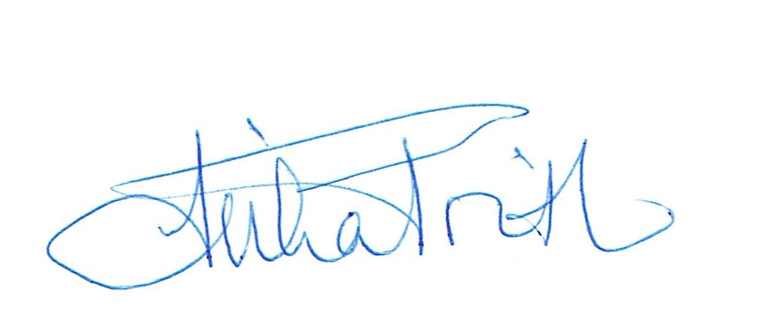

Reviewed 18/01/2024

