Environmental Policy
Just Surveys Limited accepts responsibility for the harmful effects its operations may have on both the local and global environment and is committed to reducing them. The company will adopt best practice and assist, where possible, in developing solutions to the environmental issues and problems facing its sector.
The company will conduct its activities in full knowledge of, and compliance with, the requirements of applicable environmental legislation and Approved Codes of Practice.
Just Surveys Limited will measure its impact on the environment of all past, current and likely future operations and fully integrate environmental considerations and objectives into its business decisions.
The Company will implement a training program for its staff to raise awareness of environmental issues and enlist their support in improving the Company’s performance. We will always try to encourage our staff members to become more environmentally responsible.
Just Surveys Limited will encourage the adoption of similar principles by its suppliers.

Signed
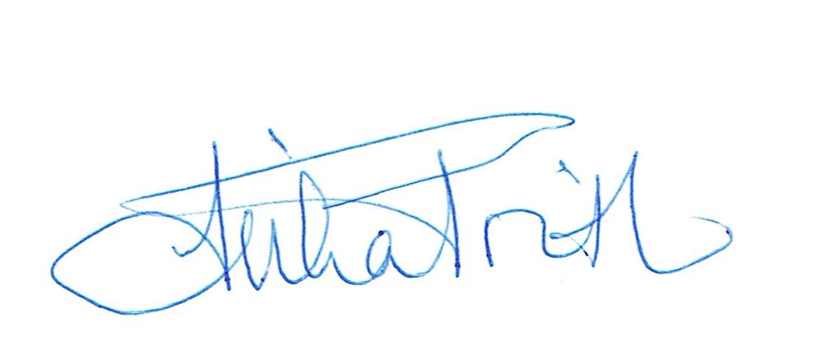

Reviewed 18/01/2024

