Complaints Handling Policy

Our complaints policy

We are committed to providing a high quality, professional and friendly service to all our clients. However, things can sometimes go wrong. When this occurs, we need you to tell us about it. This will help us to improve our standards.

If you have a complaint, please contact us with the details. We will review your complaint in accordance with our complaints procedure and will aim resolve the issue within 8 weeks.

What will happen next?

- We will send you a letter acknowledging receipt of your complaint within three days of receiving it, enclosing a copy of this procedure.

- We will then investigate your complaint. This will normally involve passing your complaint to our client care personnel, Sean Frith, who will review your issues and speak to the member of staff who undertook your drain survey or other service.

- Sean Frith will then invite you to a meeting to discuss and hopefully resolve your complaint. He will do this within 14 days of sending you the acknowledgement letter.

- Within three days of the meeting, Sean Frith will write to you to confirm what took place and any solutions he has agreed with you.

- If you do not want a meeting or it is not possible, Sean Frith will send you a detailed written reply to your complaint, including his suggestions for resolving the matter, within 21 days of sending you the acknowledgement letter.

- At this stage, if you are still not satisfied, you should contact us again and we will arrange for another director to review the decision.

- We will write to you within 14 days of receiving your request for a review, confirming our final position on your complaint and explaining our reasons.

Signed

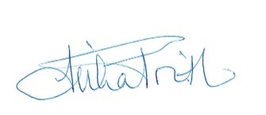

Reviewed 18/01/2024

